|  |  |
| --- | --- |
|  | **BAHRIA UNIVERSITY,**  **(Karachi Campus)**  *Department of Computer Science*  **ASSIGNMENT#01 – Fall 2022** |

Course Title: **Mobile Applications Development** Course Code: **CSC-341**

Class: **BS(IT)-6A** Shift: **Morning**

Course Instructor: **Engr. M. Adnan Ur Rehman** Time Allowed:  **01 Week.**

Dated: **02-Nov-2022** Max. Marks: **10 Points**

**Instructions:**

* This is a group assignment. Maximum three number of members are allowed per group. All members of a group MUST submit the same copy through LMS. Submission is permitted on ***LMS***.
* You must upload only compressed (.zip) version of app\src\main folder.
* Be aware of PLAGIARISM.

|  |  |
| --- | --- |
| **Enrolment#** | **Student Name** |
| 02-235201-030 | MUHAMMAD EHSAN ALI |
| 02-235201-034 | FAIZAN AHMED |
| 02-235201-022 | HASSAN RAZA |

**TASK:** Create an android application which can demonstrate all the events of activity life cycle. Your application must show event logs on main screen for all possible callbacks.

**[CLO#3, 20 points]**

**SOLUTION:**

**OUTPUT SCREEN:**

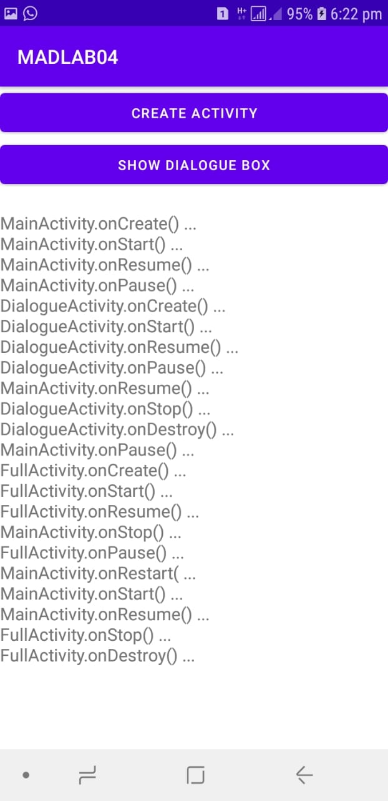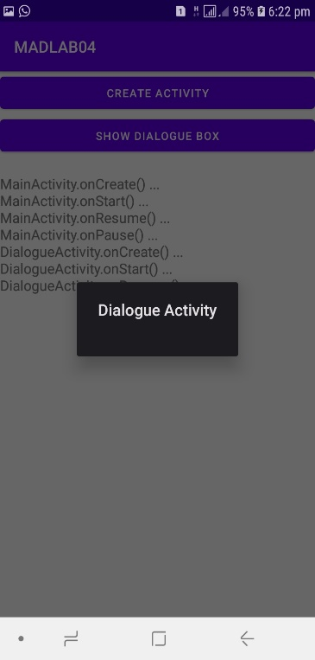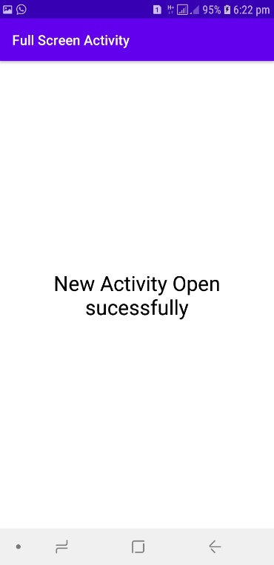

MAIN ACTIVITY:

package com.example.madlab04;  
  
import android.content.BroadcastReceiver;  
import android.content.Context;  
import android.content.Intent;  
import android.content.IntentFilter;  
import android.os.Bundle;  
import android.text.method.ScrollingMovementMethod;  
import android.view.View;  
import android.widget.TextView;  
  
import androidx.appcompat.app.AppCompatActivity;  
  
public class MainActivity extends AppCompatActivity {  
 BroadcastReceiver broadcastReceiver;  
  
 Intent intentDialogue;  
  
 Intent intentFull;  
  
 static TextView *txtLog*;  
  
 public static void addLog(String paramString) {  
 TextView textView = *txtLog*;  
 StringBuilder stringBuilder = new StringBuilder();  
 stringBuilder.append(*txtLog*.getText().toString());  
 stringBuilder.append("\n");  
 stringBuilder.append(paramString);  
 textView.setText(stringBuilder.toString());  
 }  
  
 public void onBtnDialogue(View ParamView)  
 { startActivity(intentDialogue); }  
  
 public void onBtnFull(View ParamView)  
 { startActivity(intentFull); }  
  
 protected void onCreate(Bundle paramBundle) {  
 super.onCreate(paramBundle);  
 setContentView(R.layout.*activity_main*);  
 *txtLog* = (TextView)findViewById(R.id.*textview*);  
 *txtLog*.setMovementMethod(new ScrollingMovementMethod());  
 intentDialogue = new Intent(getApplicationContext(), DialogueActivity.class);  
 intentFull = new Intent(getApplicationContext(), FullActivity.class);  
 broadcastReceiver = new BroadcastReceiver() {  
  
 public void onReceive(Context param1Context, Intent param1Intent)  
 { MainActivity.*addLog*(param1Intent.getStringExtra("sLine")); }  
 };  
 IntentFilter intentFilter = new IntentFilter("logMessage");  
 registerReceiver(broadcastReceiver, intentFilter);  
 *addLog*("MainActivity.onCreate() ...");  
 }  
  
 protected void onDestroy() {  
 super.onDestroy();  
 unregisterReceiver(broadcastReceiver);  
 *addLog*("MainActivity.onDestroy() ...");  
 }  
  
 protected void onPause() {  
 super.onPause();  
 *addLog*("MainActivity.onPause() ...");  
 }  
  
 protected void onRestart() {  
 super.onRestart();  
 *addLog*("MainActivity.onRestart( ...");  
 }  
  
 protected void onResume() {  
 super.onResume();  
 *addLog*("MainActivity.onResume() ...");  
 }  
  
 protected void onStart() {  
 super.onStart();  
 *addLog*("MainActivity.onStart() ...");  
 }  
  
 protected void onStop() {  
 super.onStop();  
 *addLog*("MainActivity.onStop() ...");  
 }  
}

FULL ACTIVITY:

package com.example.madlab04;  
  
import android.content.Intent;  
import android.os.Bundle;  
  
import androidx.appcompat.app.AppCompatActivity;  
  
public class FullActivity extends AppCompatActivity {  
 public void addLog(String paramString) {  
 Intent intent = new Intent();  
 intent.setAction("logMessage");  
 intent.putExtra("sLine", paramString);  
 sendBroadcast(intent);  
 }  
  
 protected void onCreate(Bundle paramBundle) {  
 super.onCreate(paramBundle);  
 setContentView(R.layout.*activity_full*);  
 setTitle("Full Screen Activity");  
 addLog("FullActivity.onCreate() ...");  
 }  
  
 protected void onDestroy() {  
 super.onDestroy();  
 addLog("FullActivity.onDestroy() ...");  
 }  
  
 protected void onPause() {  
 super.onPause();  
 addLog("FullActivity.onPause() ...");  
 }  
  
 protected void onRestart() {  
 super.onRestart();  
 addLog("FullActivity.onRestart( ...");  
 }  
  
 protected void onResume() {  
 super.onResume();  
 addLog("FullActivity.onResume() ...");  
 }  
  
 protected void onStart() {  
 super.onStart();  
 addLog("FullActivity.onStart() ...");  
 }  
  
 protected void onStop() {  
 super.onStop();  
 addLog("FullActivity.onStop() ...");  
 }  
}

DIALOGUE ACTIVITY:

package com.example.madlab04;  
  
import android.content.Intent;  
import android.os.Bundle;  
  
import androidx.appcompat.app.AppCompatActivity;  
  
public class DialogueActivity extends AppCompatActivity {  
 public void addLog(String paramString) {  
 Intent intent = new Intent();  
 intent.setAction("logMessage");  
 intent.putExtra("sLine", paramString);  
 sendBroadcast(intent);  
 }  
  
 protected void onCreate(Bundle paramBundle) {  
 super.onCreate(paramBundle);  
 setContentView(R.layout.*activity_dialogue*);  
 setTitle("Dialogue Activity");  
 addLog("DialogueActivity.onCreate() ...");  
 }  
  
 protected void onDestroy() {  
 super.onDestroy();  
 addLog("DialogueActivity.onDestroy() ...");  
 }  
  
 protected void onPause() {  
 super.onPause();  
 addLog("DialogueActivity.onPause() ...");  
 }  
  
 protected void onRestart() {  
 super.onRestart();  
 addLog("DialogueActivity.onRestart( ...");  
 }  
  
 protected void onResume() {  
 super.onResume();  
 addLog("DialogueActivity.onResume() ...");  
 }  
  
 protected void onStart() {  
 super.onStart();  
 addLog("DialogueActivity.onStart() ...");  
 }  
  
 protected void onStop() {  
 super.onStop();  
 addLog("DialogueActivity.onStop() ...");  
 }  
}

ACTIVITY MAIN XML

<?xml version="1.0" encoding="utf-8"?>  
<LinearLayout xmlns:android="http://schemas.android.com/apk/res/android"  
 xmlns:tools="http://schemas.android.com/tools"  
 android:layout_width="match_parent"  
 android:layout_height="match_parent"  
 android:orientation="vertical"  
 tools:ignore="ExtraText"  
 tools:context=".MainActivity">  
  
 <Button  
 android:id="@+id/btnCreate"  
 android:layout_width="match_parent"  
 android:layout_height="wrap_content"  
 android:text="Create Activity"  
 android:onClick="onBtnFull"/>  
 <Button  
 android:id="@+id/btndiabox"  
 android:layout_width="match_parent"  
 android:layout_height="wrap_content"  
 android:text="Show Dialogue Box"  
 android:onClick="onBtnDialogue"/>  
  
 <TextView  
 android:id="@+id/textview"  
 android:background="@color/cardview_light_background"  
 android:layout_width="match_parent"  
 android:layout_height="match_parent"  
 android:textSize="18sp"/>  
</LinearLayout>

FULL ACTIVITY XML:

<?xml version="1.0" encoding="utf-8"?>  
<LinearLayout xmlns:android="http://schemas.android.com/apk/res/android"  
 xmlns:app="http://schemas.android.com/apk/res-auto"  
 xmlns:tools="http://schemas.android.com/tools"  
 android:layout_width="match_parent"  
 android:layout_height="match_parent"  
 tools:context=".FullActivity">  
  
 <TextView  
 android:id="@+id/activity_full"  
 android:layout_width="match_parent"  
 android:layout_height="wrap_content"  
 android:text="New Activity Open sucessfully"  
 android:textSize="30sp"  
 android:textColor="@color/black"  
 android:layout_gravity="center_vertical"  
 android:gravity="center"  
 />  
</LinearLayout>

DIALOGUE ACTIVITY XML:

<?xml version="1.0" encoding="utf-8"?>  
<LinearLayout xmlns:android="http://schemas.android.com/apk/res/android"  
 xmlns:app="http://schemas.android.com/apk/res-auto"  
 xmlns:tools="http://schemas.android.com/tools"  
 android:layout_width="match_parent"  
 android:layout_height="match_parent"  
 tools:context=".DialogueActivity">  
  
 <TextView  
 android:id="@+id/activity_dialogue"  
 android:layout_width="match_parent"  
 android:layout_height="wrap_content"  
 android:text=""  
 android:textSize="30dp"  
 android:layout_gravity="center_vertical"  
 android:gravity="center"  
 /><?xml version="1.0" encoding="utf-8"?>  
<manifest xmlns:android="http://schemas.android.com/apk/res/android"  
 xmlns:tools="http://schemas.android.com/tools">  
  
 <application  
 android:allowBackup="true"  
 android:dataExtractionRules="@xml/data_extraction_rules"  
 android:fullBackupContent="@xml/backup_rules"  
 android:icon="@mipmap/ic_launcher"  
 android:label="@string/app_name"  
 android:roundIcon="@mipmap/ic_launcher_round"  
 android:supportsRtl="true"  
 android:theme="@style/Theme.MADLAB04"  
 tools:targetApi="31">  
 <activity  
 android:name=".MainActivity"  
 android:exported="true">  
 <intent-filter>  
 <action android:name="android.intent.action.MAIN" />  
  
 <category android:name="android.intent.category.LAUNCHER" />  
 </intent-filter>  
  
 <meta-data  
 android:name="android.app.lib_name"  
 android:value="" />  
 </activity>  
 <activity android:name=".DialogueActivity" android:theme="@style/Theme.Material3.Dark.Dialog" android:exported="false">  
 <meta-data android:name="android.app.lib_name" android:value=""/>  
 </activity>  
 <activity android:name=".FullActivity" android:exported="false">  
 <meta-data android:name="android.app.lib_name" android:value=""/>  
 </activity>  
  
 </application>  
  
</manifest>

</LinearLayout>

MAINEFEST XML:

<?xml version="1.0" encoding="utf-8"?>  
<manifest xmlns:android="http://schemas.android.com/apk/res/android"  
 xmlns:tools="http://schemas.android.com/tools">  
  
 <application  
 android:allowBackup="true"  
 android:dataExtractionRules="@xml/data_extraction_rules"  
 android:fullBackupContent="@xml/backup_rules"  
 android:icon="@mipmap/ic_launcher"  
 android:label="@string/app_name"  
 android:roundIcon="@mipmap/ic_launcher_round"  
 android:supportsRtl="true"  
 android:theme="@style/Theme.MADLAB04"  
 tools:targetApi="31">  
 <activity  
 android:name=".MainActivity"  
 android:exported="true">  
 <intent-filter>  
 <action android:name="android.intent.action.MAIN" />  
  
 <category android:name="android.intent.category.LAUNCHER" />  
 </intent-filter>  
  
 <meta-data  
 android:name="android.app.lib_name"  
 android:value="" />  
 </activity>  
 <activity android:name=".DialogueActivity" android:theme="@style/Theme.Material3.Dark.Dialog" android:exported="false">  
 <meta-data android:name="android.app.lib_name" android:value=""/>  
 </activity>  
 <activity android:name=".FullActivity" android:exported="false">  
 <meta-data android:name="android.app.lib_name" android:value=""/>  
 </activity>  
  
 </application>  
  
</manifest>